Scottish Police Authority
Gaelic Plan Survey

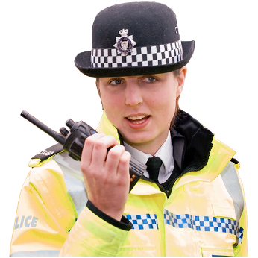

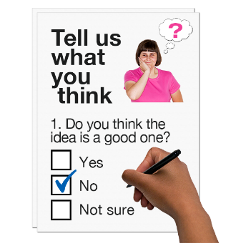

Copyright images © Photosymbols. Prepared by Disability Equality Scotland

What is this survey for?
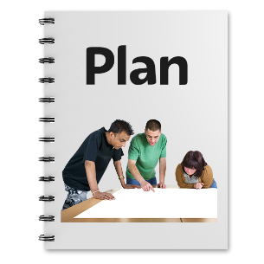  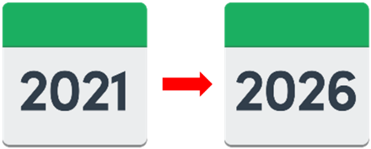 | This survey is about the Scottish Police Authority’s Gaelic Language Plan 2021-26.  The plan supports the National Gaelic Language Plan.
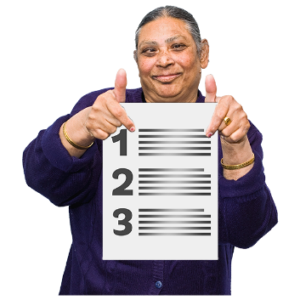 | The plan wants:  - Gaelic to be used more  - more people to learn Gaelic  - Gaelic to be seen as a positive thing.
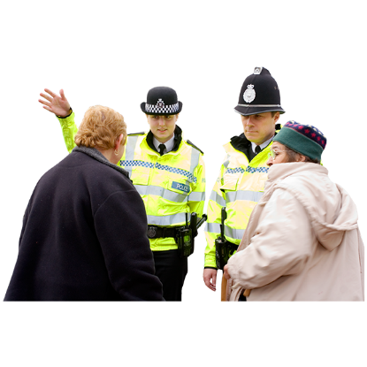 | We want to know what you think about the Scottish Police Authority using Gaelic when we communicate with people.
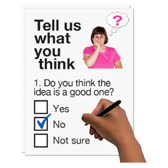 | This survey will help us listen, understand and respond to what you think.
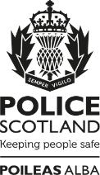 | You will also soon be able tell Police Scotland what you think for their Gaelic Language Plan 2021-26. Which, when launched, will be available here.
This survey is not about reporting crime.
There are ways to contact Police Scotland.
Find out more online at:
https://www.scotland.police.uk/contact-us/
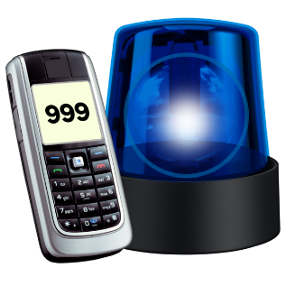 | If you need help from the Police in an emergency call 999.
How will we use your personal information?
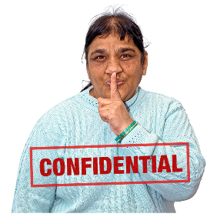 | Your replies are confidential.  This means your information will be kept private.
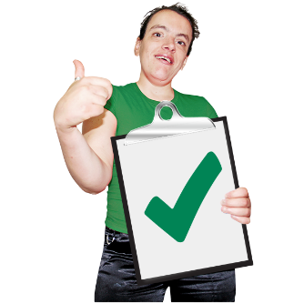 | If you fill out the survey you agree to the Scottish Police Authority using your data for their reports.  No-one will know it is your information.
How do I take part in the survey?
 | You can fill out this survey on your computer, then save it and email it to: enquiries@spa.pnn.police.uk
 | or print a copy, write in your answers then scan it and email it to: enquiries@spa.pnn.police.uk
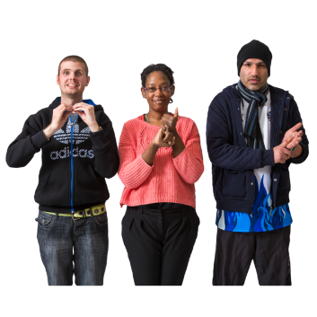 | A British Sign Language version of the survey will be available online.
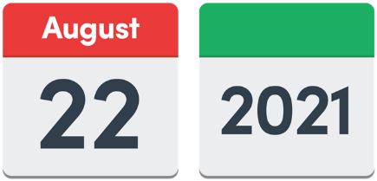 | Send us your survey before 22 August 2021.
If you have questions or if you want to do the survey over the phone please
email: enquiries@spa.pnn.uk

Click on the box of the answer you agree with and a tick will appear. ☐

If you change your mind you can click on it again to untick it.

If you are filling out a paper copy, tick the box of the answer you agree with, and if you have more to say write your answer in the ‘Write your answer here’ spaces.

Miss out a question if you do not know the answer.

You do not have to answer a question if you do not want to.

We want to know what people who speak Gaelic think about how the Police work.

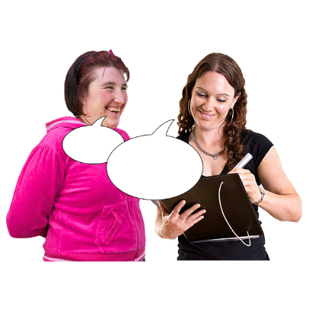 | 1. Do you think it is important that we ask people who speak Gaelic what they think and include their views?
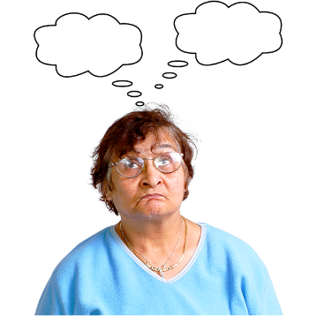 | Yes | ☐
 | I am not sure | ☐
 | No | ☐
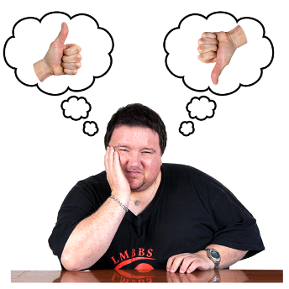 | 2. How could we encourage people who speak Gaelic to tell us what they think about police policies and the way police work?
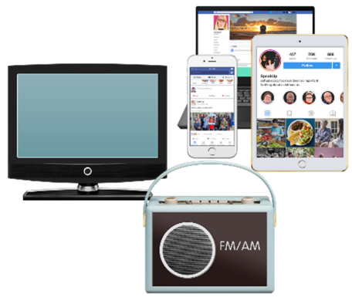  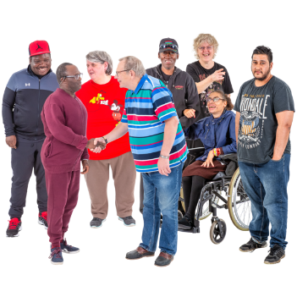  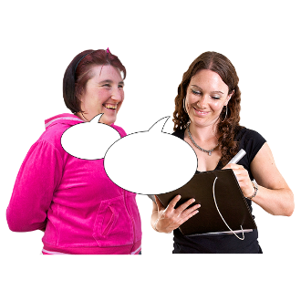 | Telling Gaelic speakers about our work and asking them to tell us what they think. | ☐
 | Working with Gaelic speaking communities and organisations representing Gaelic speakers | ☐
 | Working with Gaelic media and advertising.  This could be:  - in newspapers  - on social media  - on radio and television channels like BBC Alba. | ☐
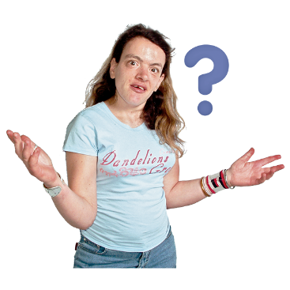 | In another way. Tell us what: | ☐
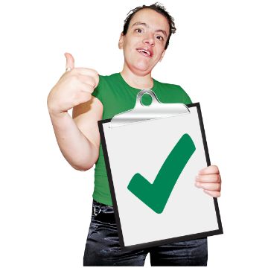 | 3. If we include the views of people who speak Gaelic is this a good way to support the use of Gaelic in Scotland?
 | Yes | ☐
 | I am not sure | ☐
 | No | ☐
4. Tell us why you think this.
Write it here:

- We will have Gaelic language awareness training for our staff.

How should we use Gaelic in our work?

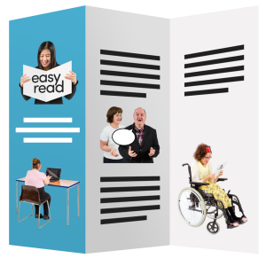  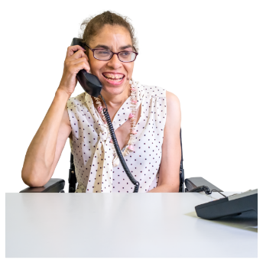 | Having Gaelic versions of our main information. | ☐
 | Telling people they can write or email us in Gaelic and we will reply in Gaelic. | ☐
 | Answering the phone with Gaelic greetings. | ☐
 | In another way. Tell us what: | ☐
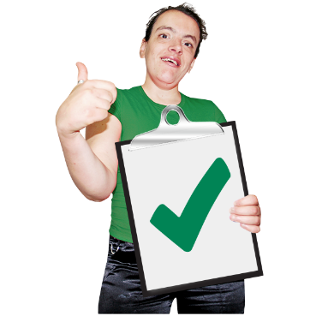 | - Do you think the draft of the Scottish Police Authority Gaelic Language Plan is positive about Gaelic?
 | Yes | ☐
 | I am not sure | ☐
 | No | ☐
7. Tell us why you think this. Write it here:

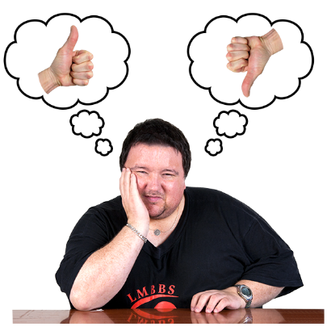 | 8. Do you agree with the work the Plan wants to do?
 | Yes all of the work | ☐
 | Yes some of the work | ☐
 | No | ☐
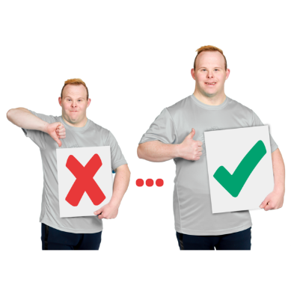 | 9. What could the Scottish Police Authority do to make the Plan better?  Write it here:
About you.

We ask these questions to make sure we get lots of different types of people answering the survey.

You do not have to answer any of these questions if you do not want to.

 | 10. Are you answering this survey:
 | - as an individual (go to question 12. | ☐
 | - or as an organisation (go to question 11)  11. Tell us the name of the organisation.  If you are answering for an organisation you are now finished the survey.  Thank you. | ☐
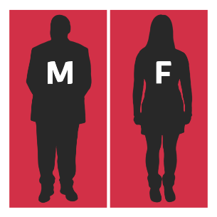 | 12. Do you think of yourself as:
 | Female | ☐
 | Male | ☐
 | Non-binary (I don’t see myself as only male or only female) | ☐
 | In another way. | ☐
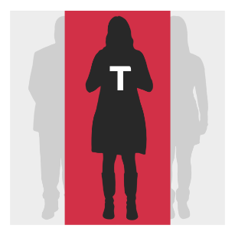 | 13. Do you think of yourself as trans or that you have a transgender history?  Transgender means you see yourself differently from your birth sex (male or female).
 | Yes | ☐
 | No | ☐
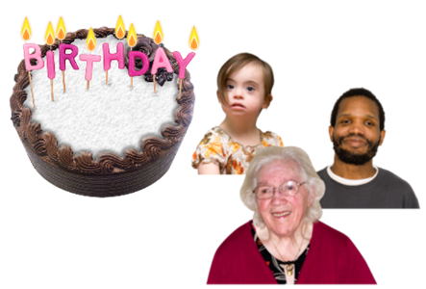 | 14. How old are you? Write it here:
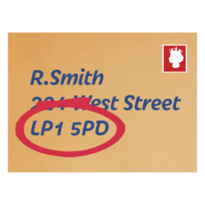 | - What is the first part of your postcode?  For example G12. Write it here:
We use postcodes for our reports.
We do not use them to find out who you are or where you live.
Your information is kept private.
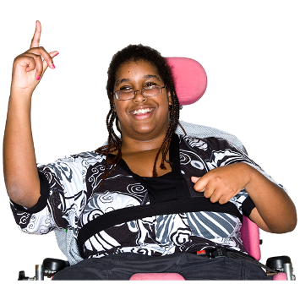 | 16. Do you consider yourself to have a disability, long-term illness or health condition?  Long term means it has lasted for over a year.  Yes ☐ go to question 17.  No ☐ go to question 18.
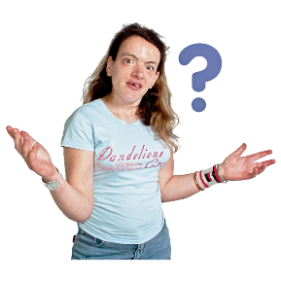 | 17. Does this disability or health condition affect you in any of these ways?
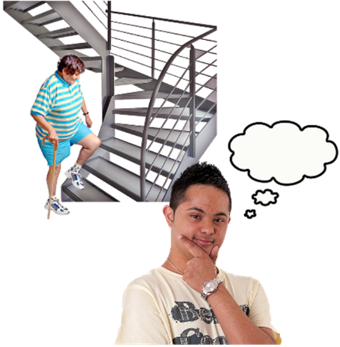  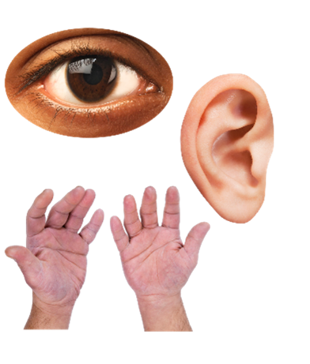 | Vision – how I see | ☐
 | Hearing | ☐
 | How I use my hands – for example if it is difficult to lift things or use a keyboard | ☐
 | Mobility – for example walking or climbing stairs | ☐
 | Learning or concentrating | ☐
 | Remembering things | ☐
 | Mental health | ☐
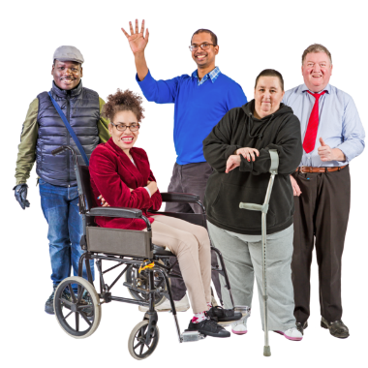 | I get out of breath or tired easily | ☐
 | How I behave around people | ☐
 | In another way. Please tell us what: | ☐
Disabled people have told us they wanted to say how their disability affected them.
We will use this information to make our service better.
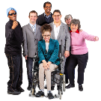 | 18. What is your ethnicity?  Ethnicity is the word we use to describe our background.  People from an ethnic group might have the same language, culture or religion.  What best describes you?  If you tick ‘other’ please tell us what your ethnicity is.
 | White
 | Scottish | ☐
 | Other British | ☐
 | Irish | ☐
 | Gypsy or Traveller | ☐
 | Polish | ☐
 | Any other white ethnic group | ☐
 | Mixed or multiple ethnic group
 | Any mixed or multiple ethnic group | ☐
 | Asian, Asian Scottish or Asian British
 | Bangladeshi, Bangladeshi Scottish, Bangladeshi British | ☐
 | Chinese, Chinese Scottish, Chinese British | ☐
 | Indian, Indian Scottish, Indian British | ☐
 | Pakistani, Pakistani Scottish, Pakistani British | ☐
 | Any other Asian | ☐
 | African
 | African, African Scottish, African British | ☐
 | Any other African | ☐
 | Caribbean or Black
 | Black, Black Scottish, Black British | ☐
 | Caribbean, Caribbean Scottish, Caribbean British | ☐
 | Any other Caribbean or Black | ☐
 | Other ethnic group
 | Arab, Arab Scottish, Arab British | ☐
 | Any other ethnic group. Write your answer here: | ☐
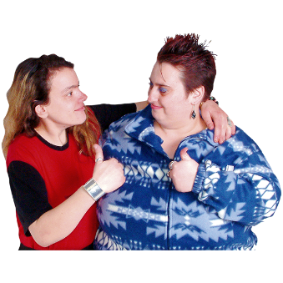 | Thank you for telling us what you think.  What you tell us is important.

Copyright images © Photosymbols. Prepared by Disability Equality Scotland

